**3-1 Milestone: Database Indexing and Authentication**

Christine R. Emerson

Department of Computer Science, Southern New Hampshire University

CS-340: Client/Server Development

Dr. Vanderburgh

July 11, 2023

**Part I: Importing and Indexing a Data Set**

1. In Apporto, open the terminal window to access the Linux shell. Upload the Austin Animal Center (AAC) Outcomes data set into MongoDB by importing a CSV file using the appropriate MongoDB import tool. Use the database name “AAC” and collection name “animals.” Complete the import using the mongoimport tool and take screenshots of both the import command and its execution.

**Import AAC Data Set CSV File into MongoDB (10,000 Documents Imported)**

1. After importing your data set, open the mongo shell. **Create a simple index** on the key “breed.” Show an example query using this index and use the **explain function** to verify that the index will be used. **Take screenshots** of your example query.

**Open the Mongo Shell and Locate the AAC dbs:**

**Create a Simple Index:**

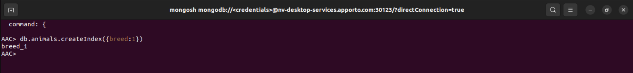

**Show an Example Query using this Index:**

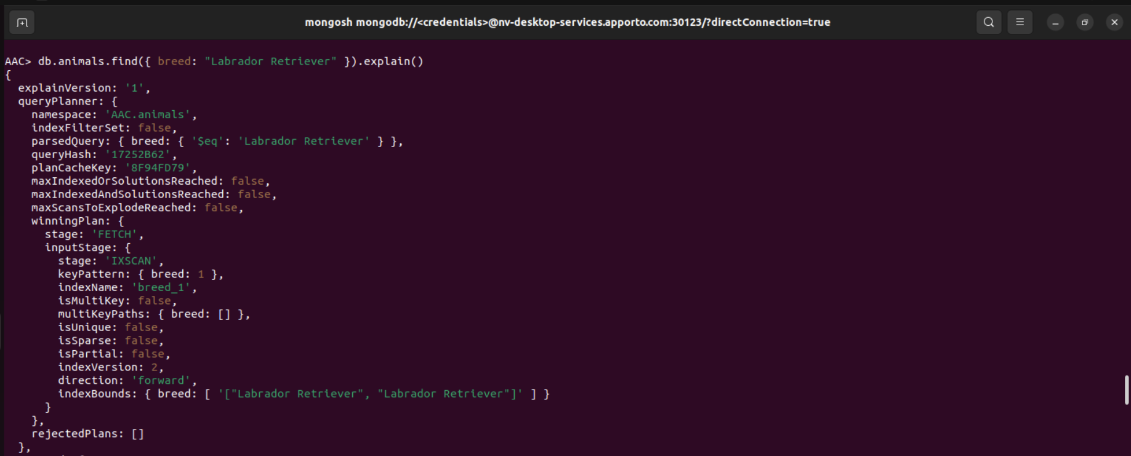

**Use the Explain Function to Confirm the Index will be used:**

1. **Create a compound index** that will improve the performance of queries looking for breeds that have an “outcome_type” of “Transfer.” Show an example query using this compound index and use the **explain function** to confirm the index will be used. **Take screenshots** of your example query.

**Create a Compound Index to Improve the Performance of Queries:**

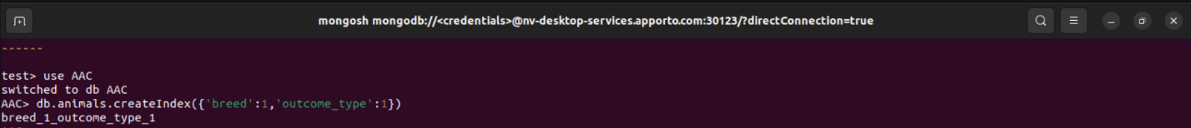

**Show an Example Query using this Index:**

**Use the Explain Function to Confirm the Index will be used:**

**Part II: User Authentication**  
The client has asked you to comply with their security needs and **ensure user authentication to the database** by setting up both **administrator and user accounts**. Your administrator account has already been configured on your database in Apporto. So, you will only have to create a user account. To do so, follow the steps below.

1. **Create a new user account called “aacuser”** for the database AAC in the mongo shell. Refer to steps 2–4 of the MongoDB [Create a User](https://www.mongodb.com/docs/v6.0/tutorial/create-users/)  tutorial for help with this task. You will need to modify the commands so the account name is “aacuser.”

**Create a New User Account Called “aacuser”:**

**Confirm the user “aacuser” was Created:**

1. Take a screenshot of your login process to MongoDB using the mongo shell. Be sure you can access MongoDB and list the databases using both the admin and aacuser accounts. This task will verify that your accounts are working. You should be able to include the login commands for both accounts in one screenshot, but if you cannot, include two screenshots to show both login commands.

**Login Process:**

**Verification that you have Connected as a Specific User:**

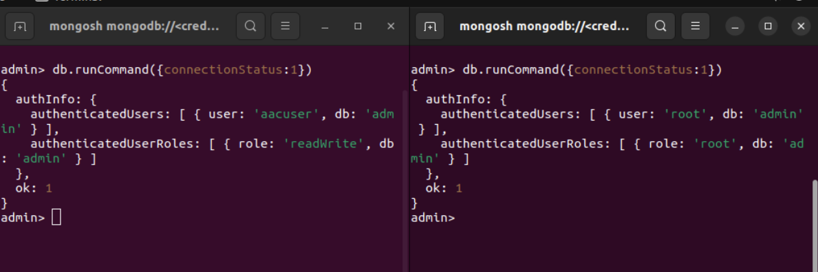

**Show Collections and List all the Databases:**

